
Company
Logotype

Cone Beam Computed Tomography- Report



Porur Dental X-rays & CBCT

Patient Name : Mr. Lokesh | Date of Report : 22.06.2024
Age/ Gender : 15 years/ Male | Region of Interest : CBCT Anterior Maxilla
Referring doctor: Dr. Muthu | Indication : Periapical lesion: 21
Clinical Notes: Nil
PATIENT INFORMATION

CBCT Anterior Maxilla provided
CBCT – IMAGE DETAILS

RADIOGRAPHIC INTERPRETATION

- Fractured crown: 21
- In relation to the periapical aspect of 21 presence of a diffuse periapical greyish hypodense area with a central area of bone destruction measuring 11.09 x14.1 x 8.04mm in dimension with an ill-defined margin is evident. The tooth 21 is present with open apex.
- The hypodense area appears to extend and spread laterally and involve the periapical aspect of 22.
- The hypodense area is present with destruction of labial cortical bone and appears to cause thinning of the palatal cortical plate and lies in close proximity to the nasal floor and incisive canal.

RADIOGRAPHIC IMPRESSION

- Fractured crown: 21
- Differential Diagnosis (based on the visible radiological features): Periapical pathology in relation to 21, 22.


Kindly correlate with clinical and histopathological features

IMAGES FOR REFERENCE

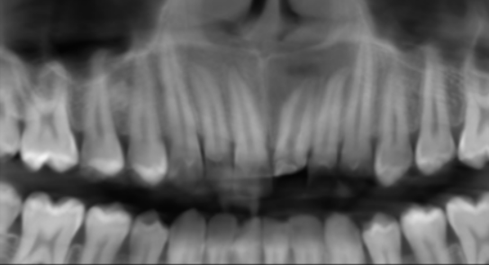

SAGITTAL IMAGES FOR REFERENCE
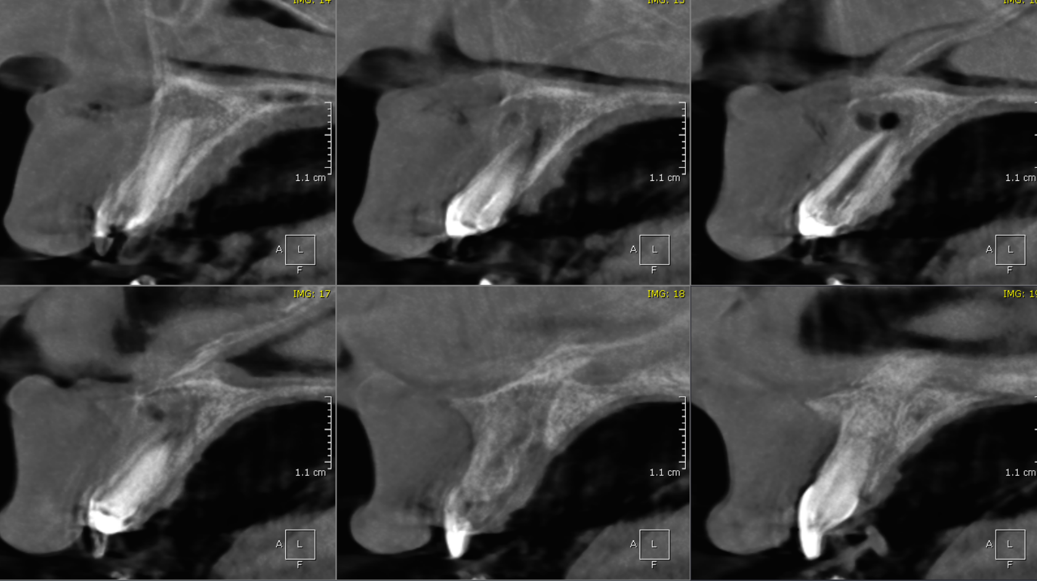
CORONAL IMAGES FOR REFERENCE
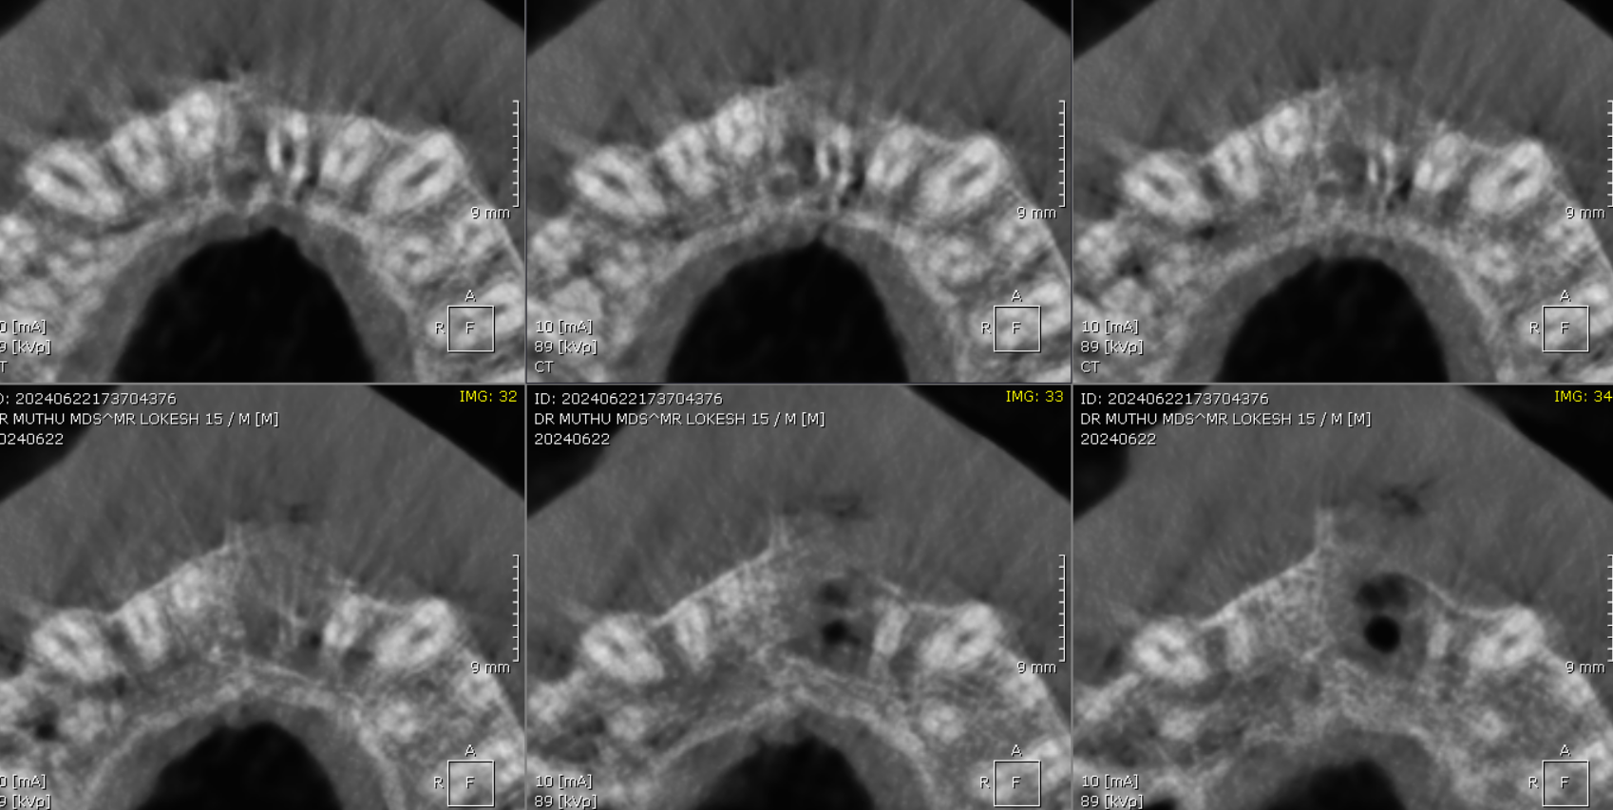
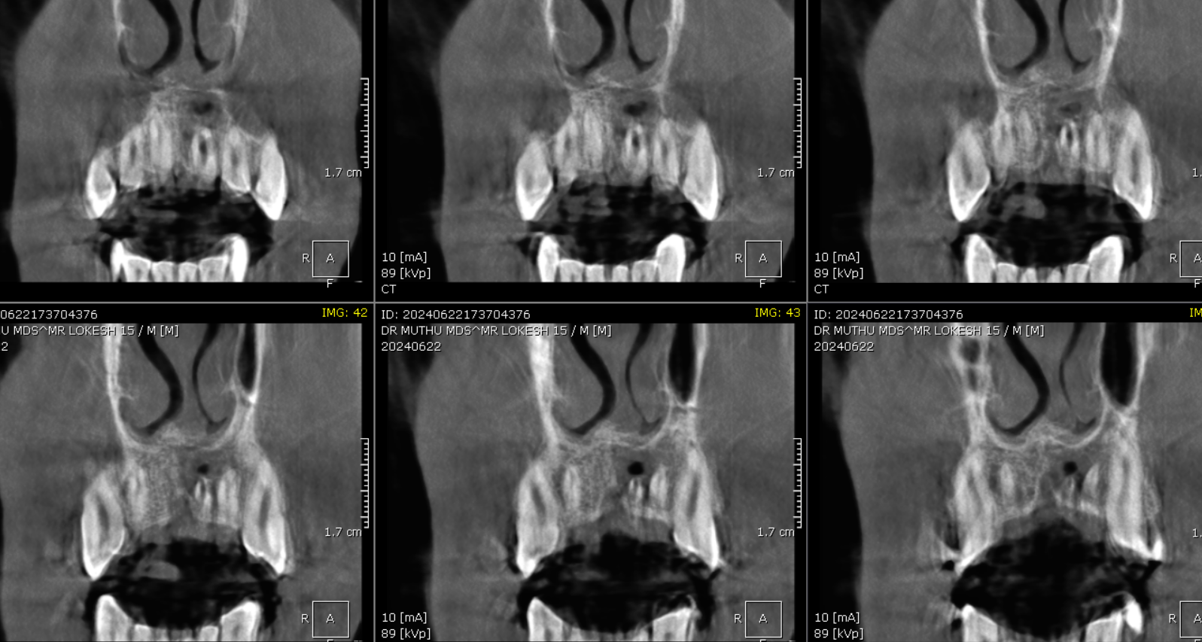
AXIAL IMAGES FOR REFERENCE
CROSS SECTIONAL IMAGES FOR REFERENCE
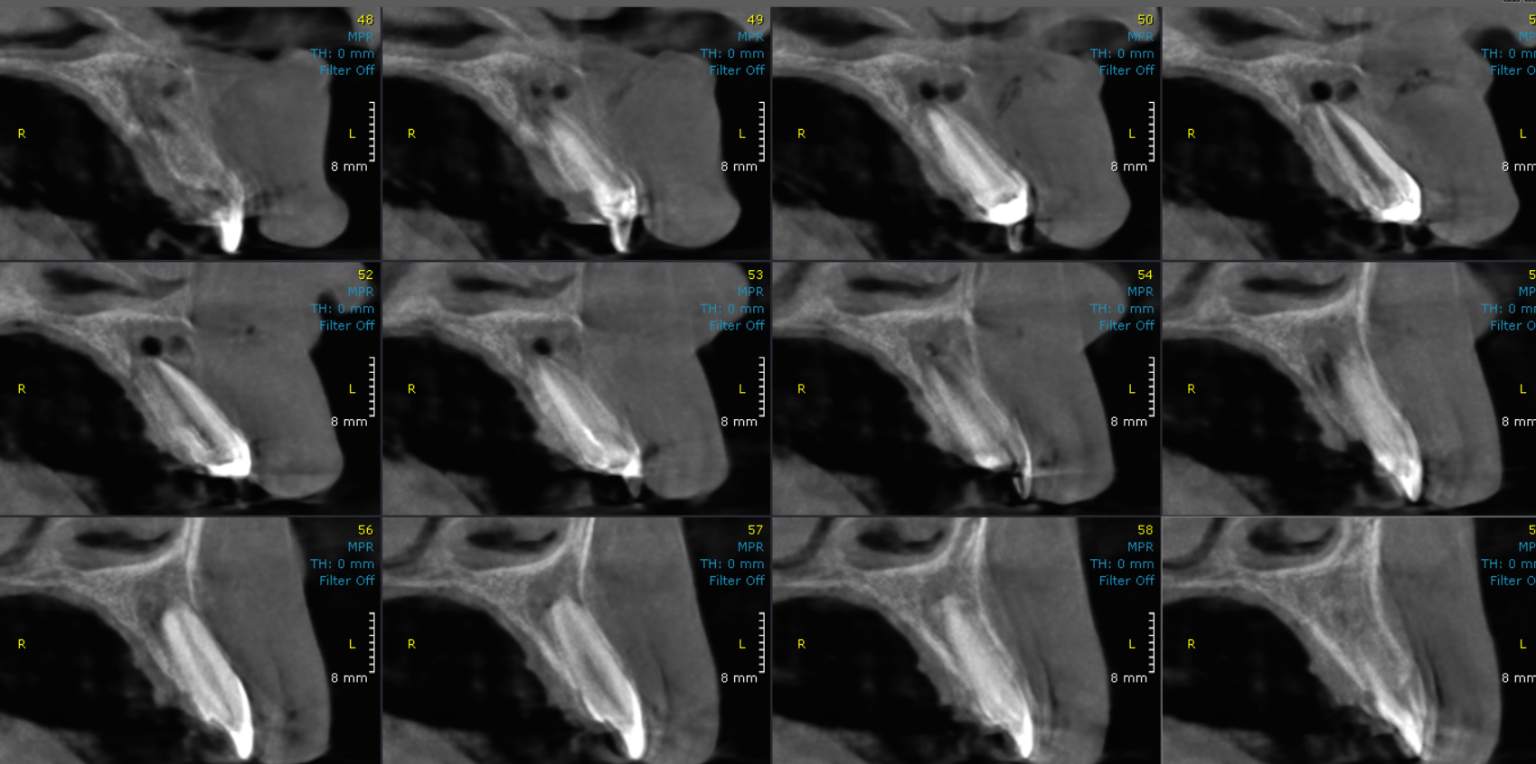
3-DIMENSIONAL VIEW

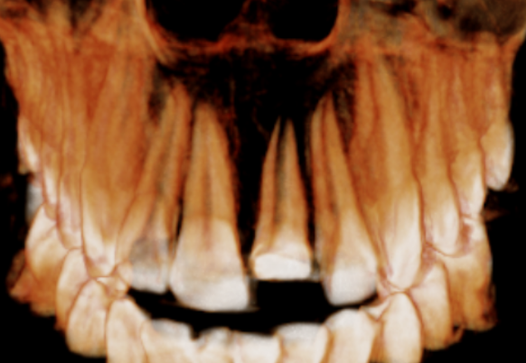

**** End of report ****

